How to Review and Approve Time Cards
- Go to https://cssi.bbo.bullhornstaffing.com/ and log in
  - Your User name will be your email and the password you created.
    - If you forgot your password click “Forgot password” and follow the instructions
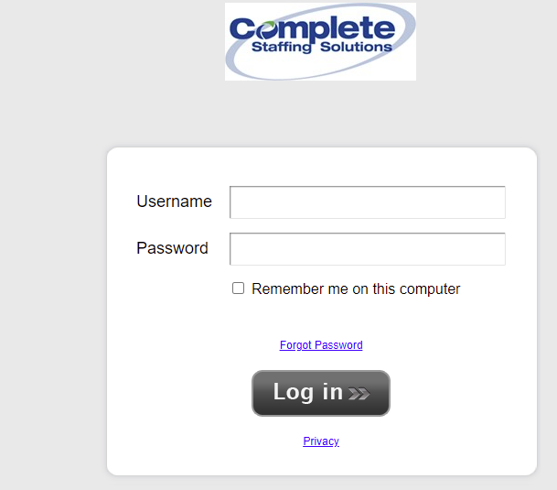
- When you login you will see Awaiting approval at the top with a list of employees time cards needing review and approval.
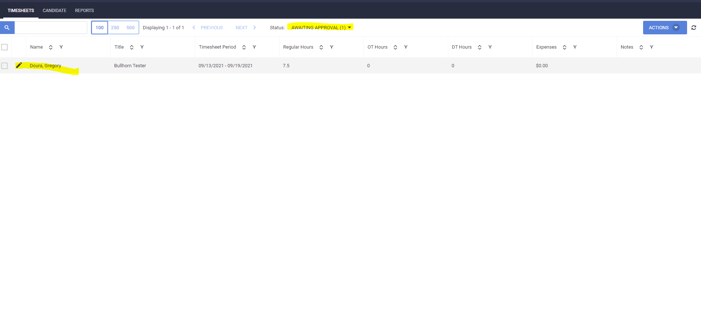
- This will break down hours by “regular hours” “OT hours” (Overtime) and “DT Hours” (Doubletime). Verify the amount of hours are correct for the week and check the box to the employees name and # click selected.

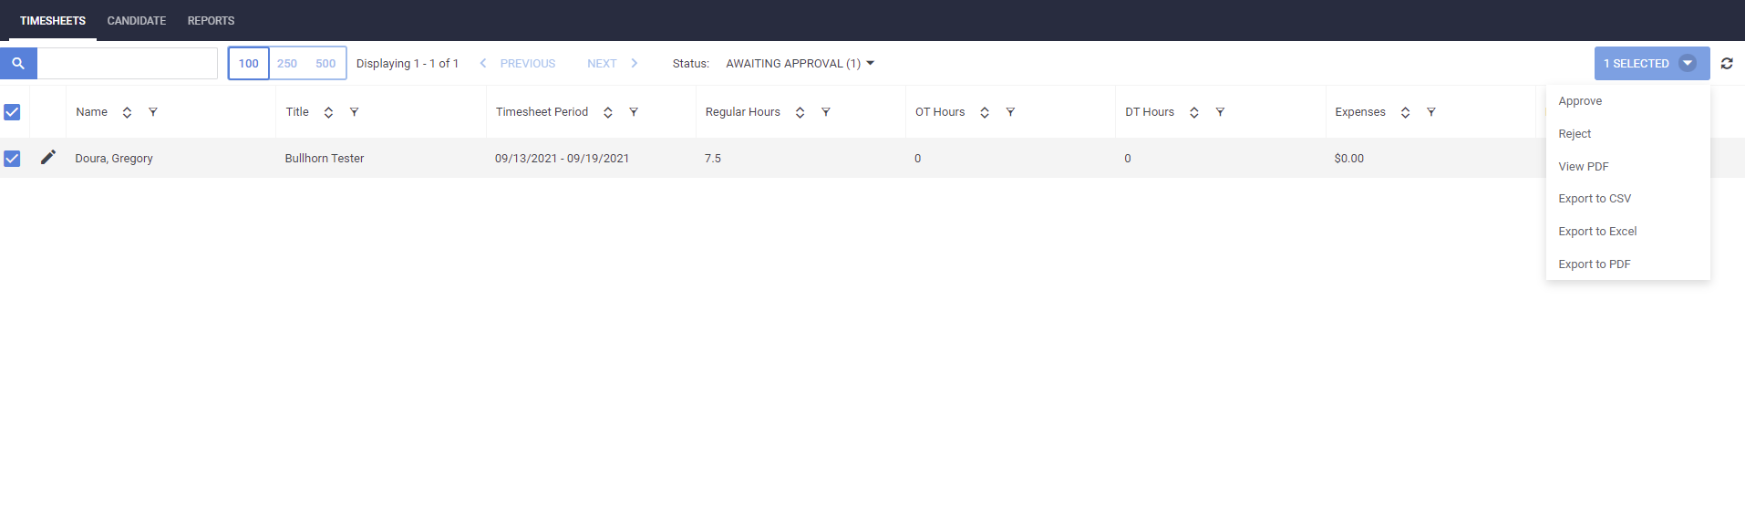
- If the hours are in correct you can click reject and type a reason why which will be sent to the candidate to correct if they are correct you can click approve which will approve their hours for the week.
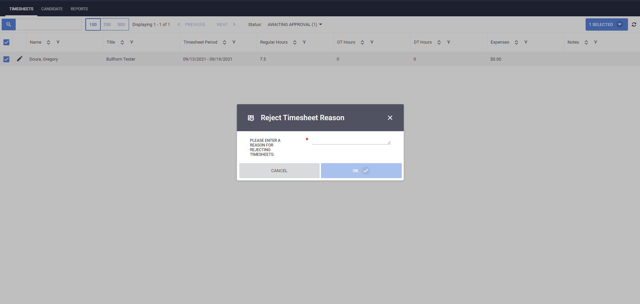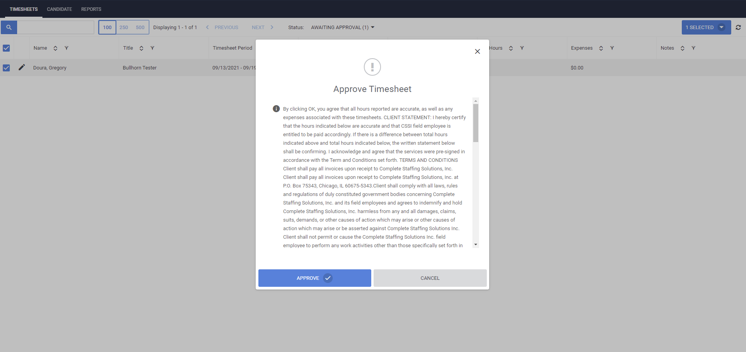

- This will be a weekly occurrence. You will receive an email for each employees time sheet that is submitted. If you have any questions please contact your Account Manager Directly.

Below are enlarged photos for better viewing below.

